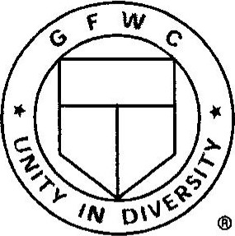
GENERAL FEDERATION
OF WOMEN'S CLUBS www.gfwc.org

CREATIVE ARTS WAIVER
With my signature I declare that:
___ I have created the submitted work, entitled and I own the full
copyright. The work has not been published before
___.With my work, including pictures, tables, or additional media, I do not violate or infringe the copyright of other persons or entities.
The work in question is (please check one) ___ Photography ___ Poetry ___ Short Story
____ I grant the General Federation of Women's Clubs a royalty-free perpetual license to use, reproduce, post, display, create derivative works, sell, license, or sub-license the work in any media now known or later invented without limitation, for commercial or non-commercial purposes.
____ 1 agree that I shall not release the work to any other publication in the same or substantially similar form, without prior written and explicit consent from the General Federation of Women's Clubs.
This agreement shall become effective and binding at the date of formal acceptance of the work for publication by the General Federation of Women's Clubs.
Signature Date
Parent/Guardian Signature (if submitter is under 18 years of age) Date

